**ST.XAVIER**’**S COLLEGE**

**(Affiliated to Tribhuvan University)**

**Maitighar, Kathmandu**





**LAB ASSIGNMENT OF DBMS #5**



**SUBMITTED BY:**

**Pradeep Dahal**

**017BSCIT0****29**

**Objective:**

|  |  |  |
| --- | --- | --- |
| Submitted To | Signature | Remarks |
| Er. Sarjan MaharjanLecturer, Dept. of Computer Science |  |  |

**To create views, drop views and perform different queries using views**

**Theory:**

**SQL VIEWS:**

A view is nothing more than a SQL statement that is stored in the database with an associated name. A view is actually a composition of a table in the form of a predefined SQL query.

A view can contain all rows of a table or select rows from a table. A view can be created from one or many tables which depends on the written SQL query to create a view.

Views, which are a type of virtual tables allow users to do the following −

* Structure data in a way that users or classes of users find natural or intuitive.
* Restrict access to the data in such a way that a user can see and (sometimes) modify exactly what they need and no more.
* Summarize data from various tables which can be used to generate reports.

**CREATE VIEWS:**

Database views are created using the CREATE VIEW statement. Views can be created from a single table, multiple tables or another view.

To create a view, a user must have the appropriate system privilege according to the specific implementation.

The basic CREATE VIEW syntax is as follows

CREATE VIEW view_name AS

SEELECT column1, column2……

FROM table_name

WHERE [condition];

### DELETING VIEWS:

Obviously, where you have a view, you need a way to drop the view if it is no longer needed. The syntax is very simple and is given below :

DROP VIEW view_name;

1. **Create a view which contains information about employee’s fullname, email and office city location.**

CREATE VIEW question1 AS

SELECT CONCAT(e.firstName,' ' ,e.lastname) AS NAME , e.email , o.city

FROM employees e, offices o

WHERE e.officeCode=o.officeCode;

**Output:**

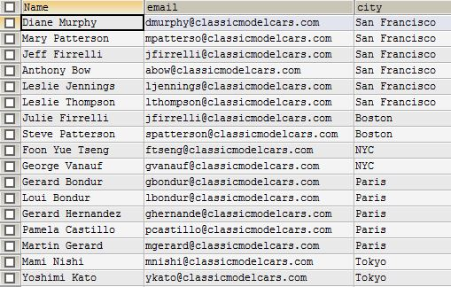

1. **Create a view that contains information about customerNumber, customerName, Full contact name, orderNumber, order status and total amount of each order.**

CREATE VIEW question2 AS

SELECT c.customerNumber, c.customerName,CONCAT(c.contactFirstName,' ',c.contactLastName) AS 'Full Contact Name', o.orderNumber, o.status, SUM(quantityOrdered*priceEach) AS 'Total Amount'

FROM customers c, orders o, orderdetails od

WHERE c.customerNumber=o.customerNumber AND o.orderNumber=od.orderNumber

GROUP BY c.customerNumber ORDER BY c.customerNumber;

**Output:**

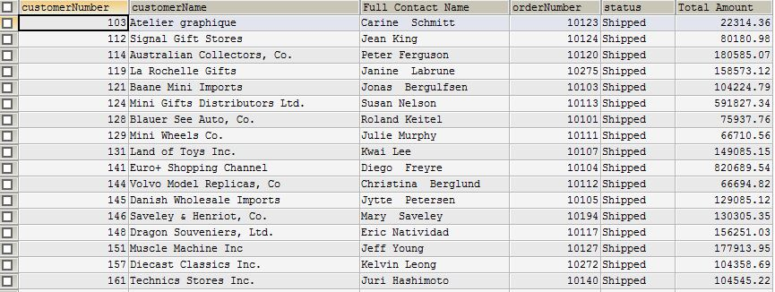

1. **Create a view that contains information about customer name, customer city, product name and quantity of given product ordered by each customers.**

CREATE VIEW question3 AS

SELECT c.customerName, c.city, p.productName, SUM(od.quantityOrdered)

FROM customers c, orders o, orderdetails od, products p

WHERE c.customerNumber = o.customerNumber AND o.orderNumber = od.orderNumber AND od.productCode=p.productCode

GROUP BY p.productName

ORDER BY c.customerName;

**Output:**

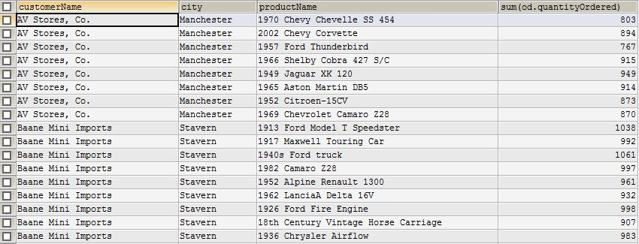

1. **Create a view that contains information about customer number, customer name, total amount paid by each customer.**

CREATE VIEW question4 AS

SELECT c.customerNumber, c.customerName, SUM(p.amount) AS 'Total_Amount_Paid'

FROM customers c, payments p

WHERE c.customerNumber=p.customerNumber

GROUP BY c.customerNumber ;

**Output:**

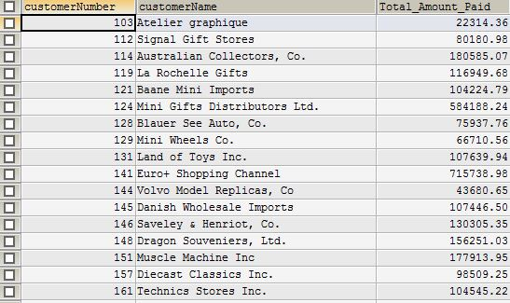

1. **Create view that contains information about product details for products ordered by customer residing in city ‘NYC’.**

CREATE VIEW question5 `lab6`AS

SELECT p.*

FROM customers c, orders o, orderdetails od, products p

WHERE c.customerNumber = o.customerNumber AND o.orderNumber = od.orderNumber AND od.productCode=p.productCode

AND c.city = 'NYC' GROUP BY p.productCode;

**Output:**

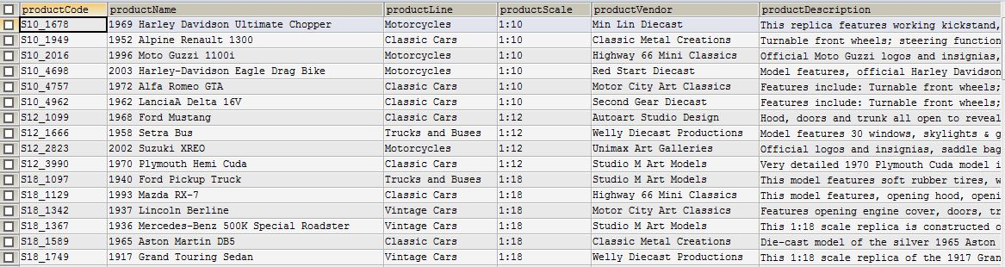

1. **Update view in question number 1 to add information about employee’s job title.**

CREATE OR REPLACE VIEW question1 AS

SELECT CONCAT(e.firstName,' ' ,e.lastname) AS NAME , e.email , o.city, e.jobTitle

FROM employees e, offices o

WHERE e.officeCode=o.officeCode;

**Output:**

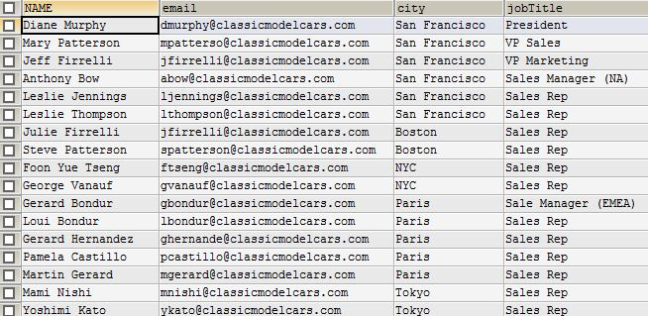

1. **Update view in question number 5 to information about product details for products ordered by customer residing in city ‘Las Vegas’ and ‘San Francisco’.**

CREATE OR REPLACE VIEW question5 AS

SELECT p.*

FROM customers c, orders o, orderdetails od, products p

WHERE c.customerNumber = o.customerNumber AND o.orderNumber = od.orderNumber AND od.productCode=p.productCode

AND (c.city = 'Las Vegas' OR c.city = 'San Francisco') GROUP BY p.productCode;

**Output:**

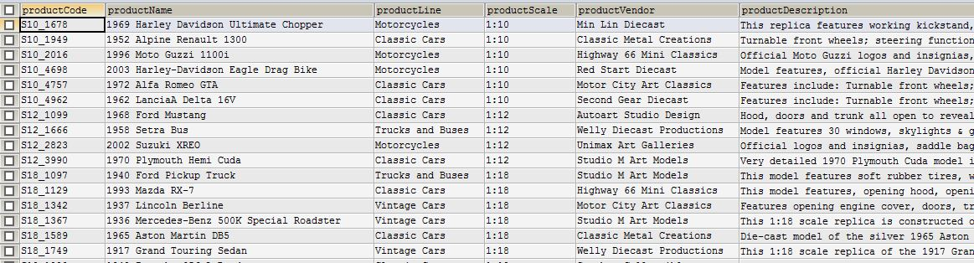

1. **Using view created in question number 4, find out the total amount paid by customer in each city.**

CREATE OR REPLACE VIEW question4 AS

SELECT c.customerNumber, c.customerName, SUM(p.amount) AS 'Total_Amount_Paid', c.city

FROM customers c, payments p

WHERE c.customerNumber=p.customerNumber

GROUP BY c.city ORDER BY c.city ;

**Output:**

